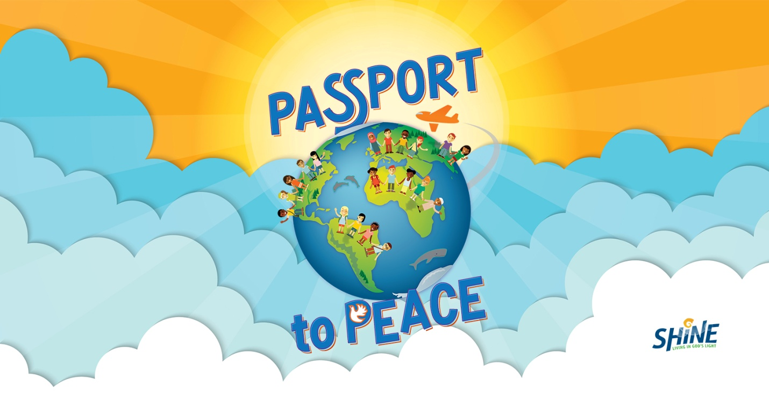
Vacation Bible School
August 1-5 9:00-12:00
First Baptist Church
445 Burnside Ave., Norristown

Bible Stories Music Games Snacks Crafts
Learn Peacemaking Skills

Register Now: https://vbsmate.com/FBCNorristown

